Databricks Apps

Minimal deployable app

- Steps Created a Customer Sales Data Bricks Table : tiger_assignment.tiger_bronze.sales_transactions
transaction_id | customer_id | customer_name | product_id | product_name | country | sales_amount | quantity | sales_date
TXN001 | C001 | Walmart | P101 | Pepsi 500ml | USA | 1200.5 | 100 | 1/5/2026
TXN002 | C002 | Carrefour | P102 | Pepsi Max | France | 950 | 80 | 1/6/2026
TXN003 | C003 | Tesco | P103 | 7UP | UK | 820.75 | 70 | 1/7/2026
TXN004 | C001 | Walmart | P104 | Mountain Dew | USA | 1500.25 | 120 | 1/8/2026
TXN005 | C004 | Aldi | P101 | Pepsi 500ml | Germany | 1100 | 90 | 1/9/2026
TXN006 | C005 | Target | P103 | 7UP | USA | 750 | 60 | 1/10/2026
TXN007 | C002 | Carrefour | P104 | Mountain Dew | France | 1350.5 | 110 | 1/11/2026
TXN008 | C006 | Lidl | P102 | Pepsi Max | Spain | 980 | 85 | 1/12/2026
TXN009 | C003 | Tesco | P101 | Pepsi 500ml | UK | 1250 | 100 | 1/13/2026
TXN010 | C004 | Aldi | P104 | Mountain Dew | Germany | 1450.75 | 115 | 1/14/2026

- Deployed the App using Stream lit to query the table.
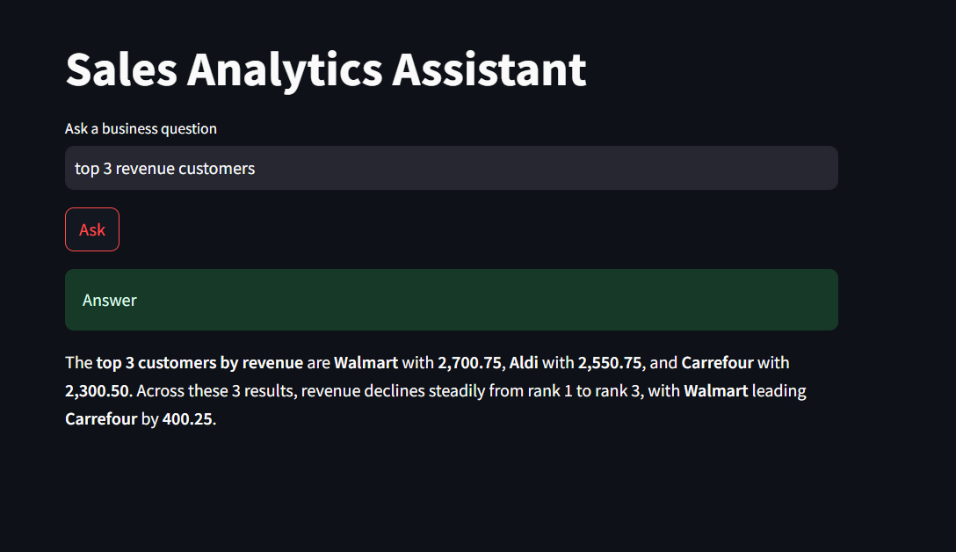

Front-end for Genie/RAG
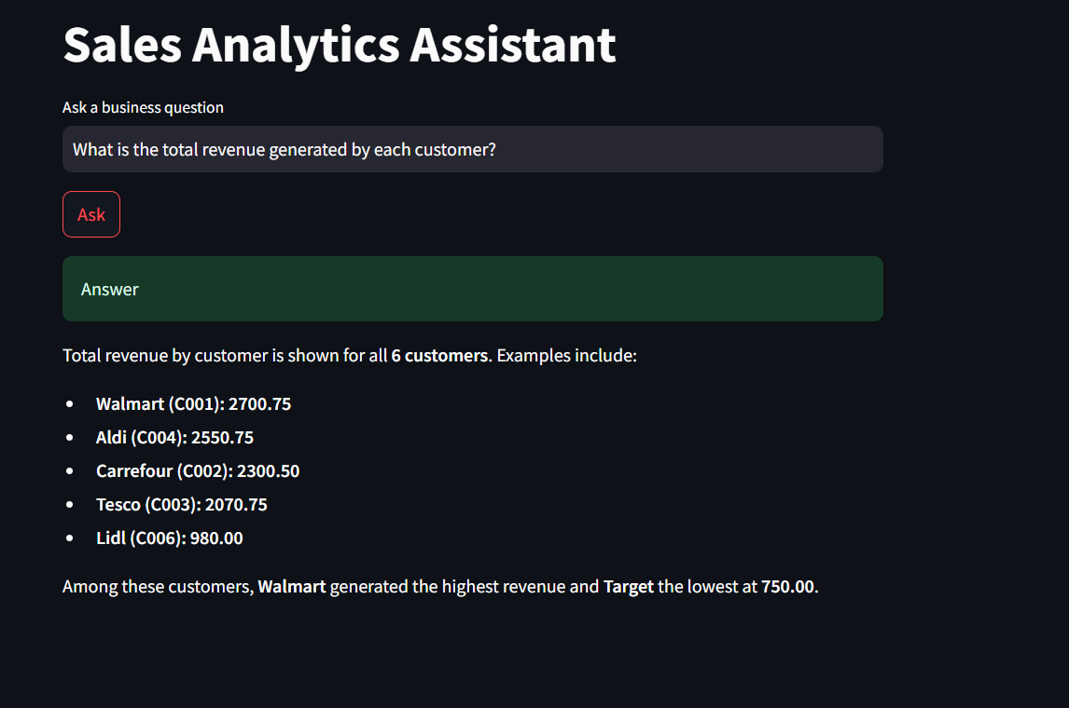
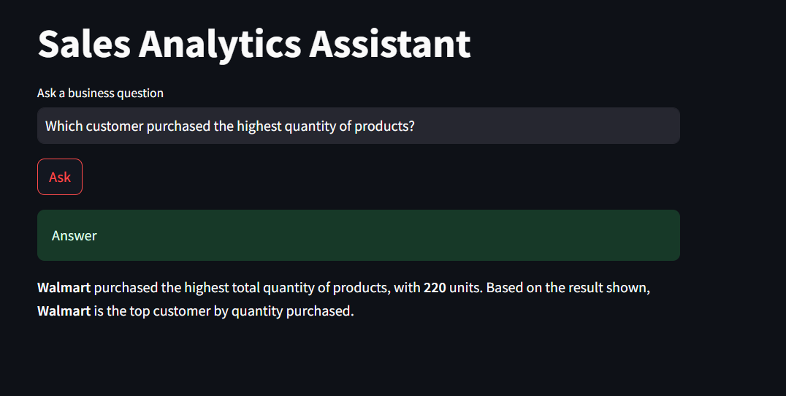

Model-serving integration:
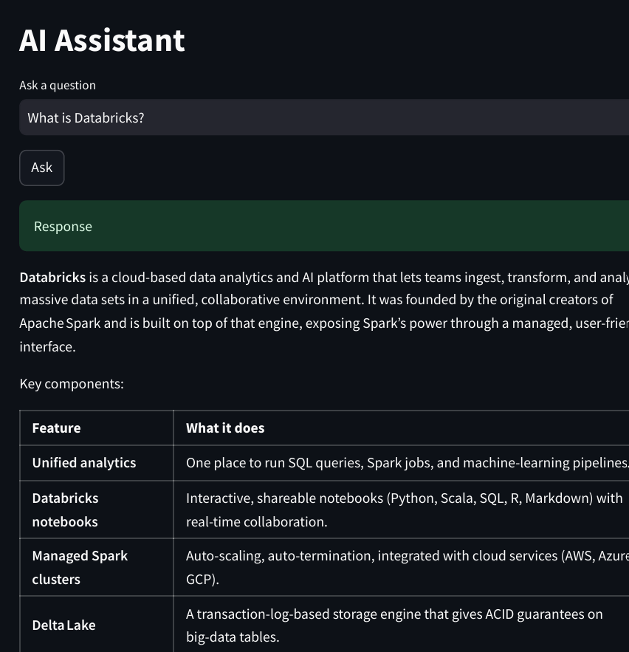

Access control test
Created Two users:
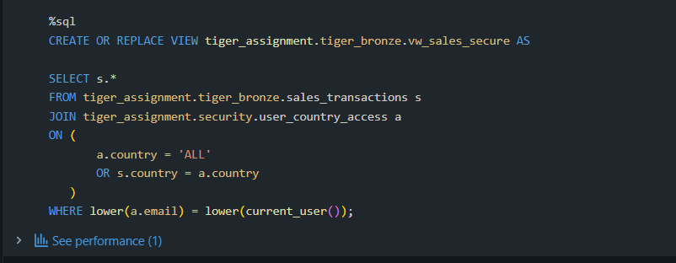

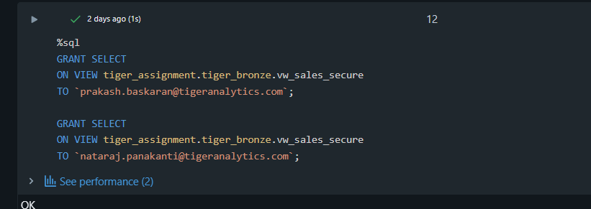

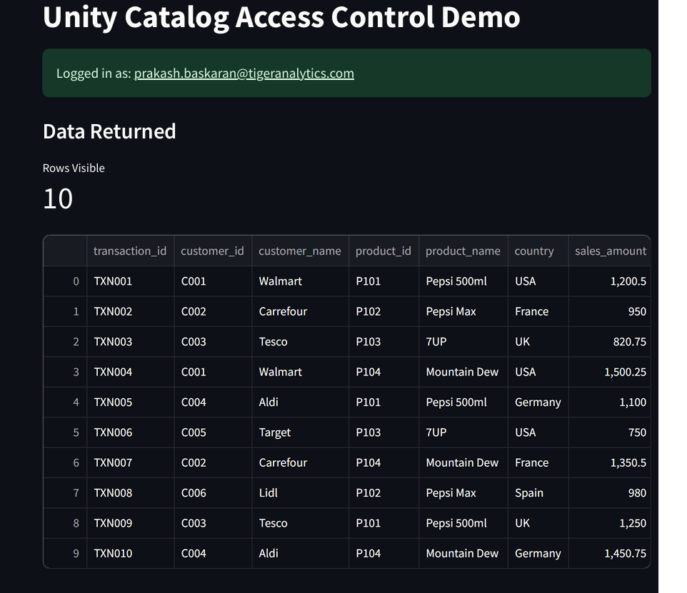

Live iteration Filter:


